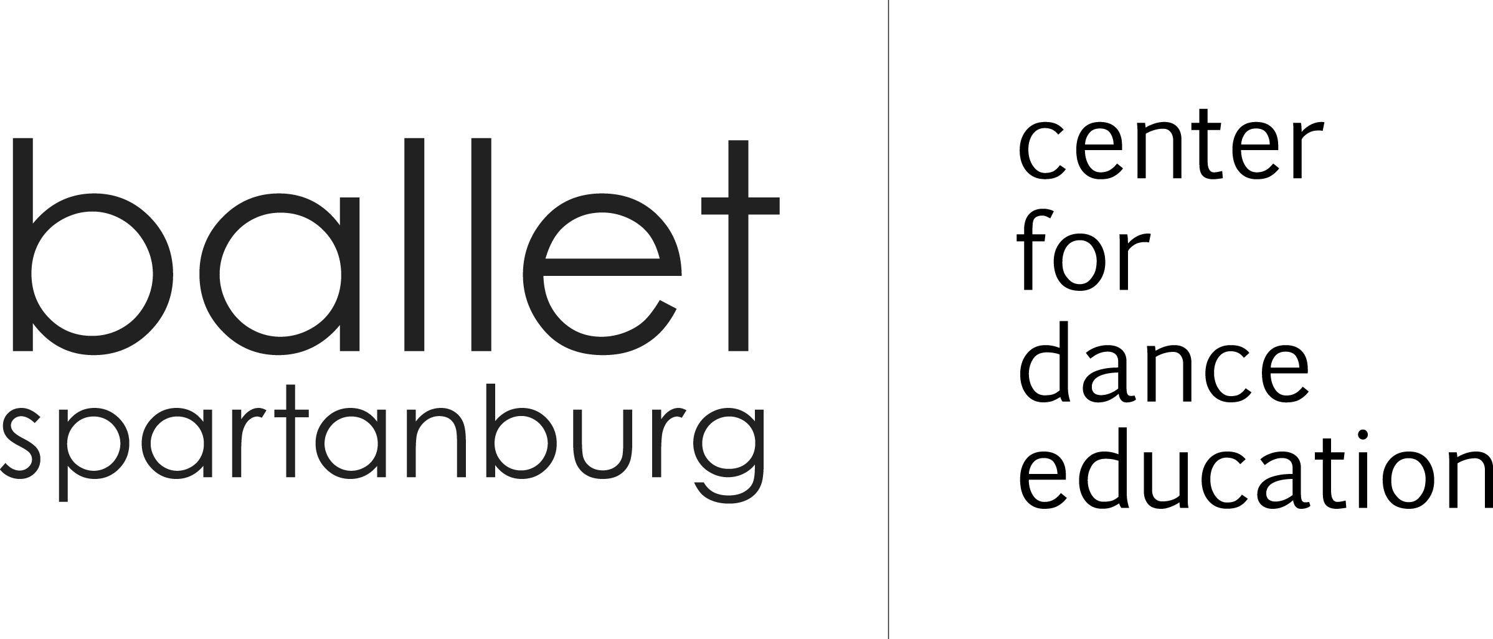
2020 WINTER CAMP REGISTRATION FORM

Please print and complete in full for each student:
______________________________________________________________ __________________________________________________________________
Student Name Sibling(s) attending Camp and Care

______________________________________________________________ _________________________________________________________________
Parent/Guardian Name(s) Parent’s Employer

_________________________________________________ ________________________________________ ____________ _________________
Home Address City State Zip

_____________________________________________________________ __________________________________________________________________
Email #1 (Required) Email #2

_____________________________________________________________ __________________________________________________________________
Phone #1: □ Home □Work □Cell Phone #2: □ Home □Work □Cell

_______________ _________________________ ____________________________________________________ __________________________
Student’s Age Student’s Date of Birth Academic School Grade
______________________________________________ ____________________________________________________ __________________________

Emergency Contact Name Relationship to Student Phone
Date(s) of Camp(s) | Camp Name and Session | Instructor | Camp Fee

- COVID-19 Waivers for Ballet Spartanburg and Chapman Cultural Center are required.
- Classes will have limited capacity for COVID-19 protocol.
- Refund policy: 10 days prior to camps date, 75% refund less a $10 handling charge. 3-9 days prior, 50% refund less a $10 handling charge. 3 days prior, no refund. Ballet Spartanburg reserves the right to cancel the camp and refund 100% tuition.

FOR OFFICE USE ONLY
Date Pd.________ Amount Pd._________ Staff Member_______ Check ☐ Chk.#_________ Cash ☐ Credit Card ☐

Student/Students Name:_____________________________________________________________________________________________________

Medical Release

Does student have any known allergies? No____ Yes___ If yes, please list

Is student currently taking medication: No____ Yes____ If yes, please list

Please describe any medical conditions that we should be aware of:

Is student physically fit to participate in movement class?

I am the parent or legal guardian and I understand that dance and creative movement involve physical contact between participants, that serious accidents occasionally occur during such activities, and that participants in such activities occasionally sustain serious personal injuries (including death) and/or property damage as a consequence thereof. Knowing the risks of participation, I hereby agree that my minor child and I assume those risks and release and hold harmless Ballet Spartanburg and its agents, sponsors and employees who might otherwise be liable to me, my minor child (or our heirs or assigns) for damages. In the event of an accident or illness involving my minor child or myself, I hereby authorize Ballet Spartanburg to arrange for transportation of my minor child or myself, whether by ambulance or otherwise, to a proper facility where emergency medical treatment would normally be administered, including but not limited to, an emergency room of a hospital, a doctor’s office, or medical clinic: and sign releases as may be required in order to obtain any medical or surgical treatment as is immediately required in the judgment of medical authorities at the facility. I agree neither my minor child nor I will make a claim against, sue, attach the property of or prosecute Ballet Spartanburg, their agents, sponsors or employees for damages, death, personal injury or property damages which my minor child may sustain as a result of my child’s participation in these activities.

I attest that I am eighteen years old or older and that my child is physically fit and has no known medical conditions which prohibit participation in these activities. My child and I agree to follow all laws, rules and guidelines regulating the conduct of Ballet Spartanburg participants.

I have carefully read this agreement and fully understand its contents. I am aware that this is a release of liability from myself and my child and a contract between myself, my child, and Ballet Spartanburg and its agents, sponsors and employees, and I have signed it of my own free will.

Signature: Date:
Photo/Video/Electronic Disclosure
For valuable consideration herein acknowledged as received, I hereby grant to Ballet Spartanburg and its legal representatives ownership of any and all photographs taken of my child during camp.

I also grant to Ballet Spartanburg and its legal representative’s permission to use, reproduce, or publish the photographs for any purpose whatsoever, without further compensation.

I hereby warrant that I am the parent/guardian and have every right to contract in the above regard. I state that I have read the above authorization, release and agreement and fully understand the contents thereof.

I/We hereby understand and accept the risk of sending any electronic devices such as laptops, computers, Ipads, cellphones or any device needed for the camp/instruction. I/We hereby do not hold Ballet Spartanburg and its agents, sponsors and employee responsible should any damage occur to any device I/We send for camp instruction.

This release shall be binding upon me, my respective heirs, legal representatives and assigns.

Signature: Date:

COVID-19 Acknowledgement and Waiver

For the safety of our students, parents, staff and employees, please answer the questions listed below. If you cannot answer YES to all of the questions, please wait until you can. Most common symptoms for COVID-19 include: Fever, Fatigue, Dry Cough, Loss of Smell/Taste, Difficulty Breathing, Runny Nose, Headache, Body Aches, Sore Throat

- I affirm that I have not had any of the symptoms listed above for 14 days.

YES

- I affirm that I, as well as anyone in my household, have not been diagnosed with COVID-19 in the past 30 days.
YES

- I affirm that I, as well as anyone in my household, have not been out of the country or to any other city considered a “hotspot” in the past 30 days.

YES

- I affirm that I, as well as anyone in my household, have not been knowingly exposed to someone diagnosed with COVID-19 in the past 30 days.

YES
- I will inform Ballet Spartanburg immediately of any COVID-19 changes in my household while my student is enrolled in camp or dance class to ensure the safety of everyone at Ballet Spartanburg.

YES

- INDEMNITY: Student (adult or minor and minor’s parents or legal guardian) shall release, indemnify, defend and hold Spartanburg Ballet (including its officers, directors, agents and employees) harmless from and against any and all liabilities, claims, penalties, damages, expenses, attorney’s fees, and judgement by reason of injury, COVID-19 or related illness and/or damage or claim of injury and/or damage to persons or property arising out of (1) dance lessons at the Ballet Spartanburg premise or other premise designated for rehearsals and/or performances.
- I have read and fully understand the above information for Ballet Spartanburg.

Name_____________________________________________________
Date______________________________________________________

