

Summer Shag Classes 2026
Learn South Carolina’s State Dance
Mondays: 6:30-7:30 p.m.
June 8, 15, 22, 29 & July 6, and 13

Grab a partner and learn how to dance the night away!
Glenn Gordy, Instructor
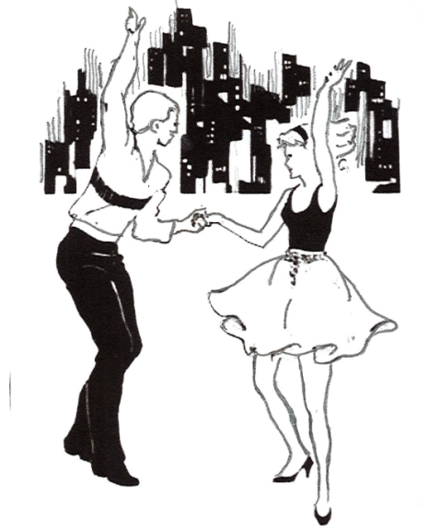

Single:$90 or Couple:$150

Name(s)
Address
Email
Cell phone
Payment Check Cash

CC: MASTERCARD VISA
Name on card
CC NUMBER CVV
EXP. ZIP CODE

200 East Saint John Street | Spartanburg SC 29306 | 864-583-0339 | balletspartanburg.org

