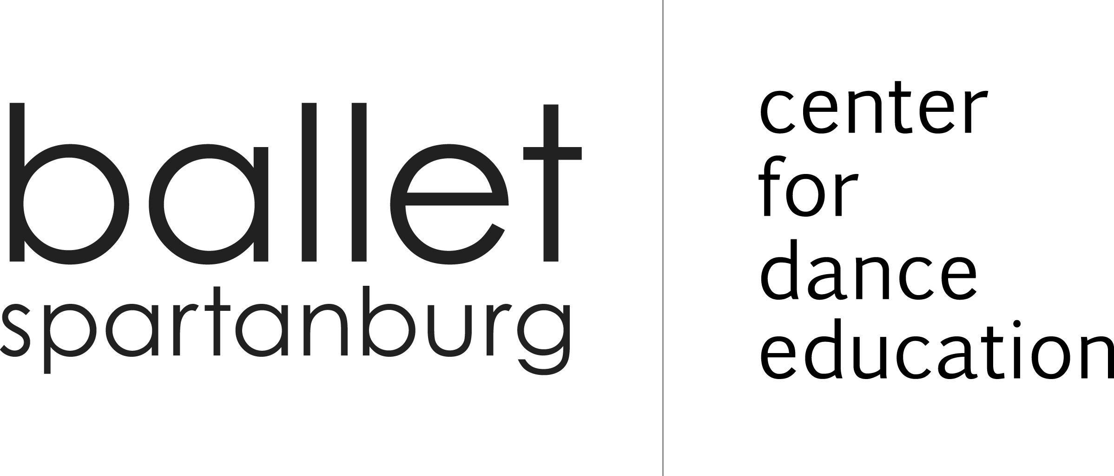

Summer Shag Classes 2022
Learn South Carolina’s State Dance
Tuesdays: 7 - 8 p.m.
June 14, 21, 28 &
July 5, 12, 19
Grab a partner and learn how to dance the night away
Marian Norman, Instructor
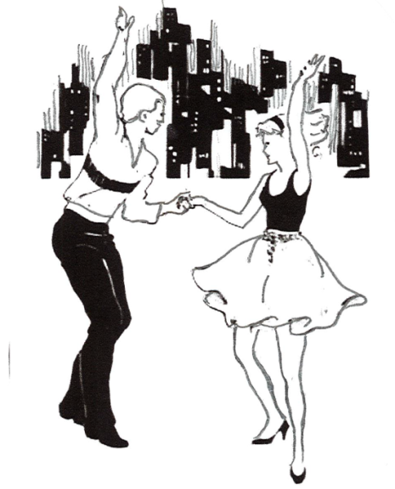

Single: $72 or Couple: $120

Name(s)
Address
Email
Cell phone
Payment Check Cash

CC: MASTERCARD VISA
Name on card
CC NUMBER CVV
EXP. ZIP CODE

200 East Saint John Street | Spartanburg SC 29306 | 864-583-0339 | balletspartanburg.org

