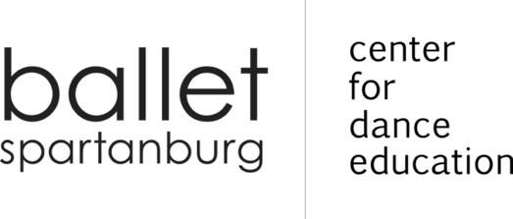
2022-2023 ADULT BALLROOM SCHEDULE

BALLROOM DANCE
MONDAYS 7:00 - 8:00 PM
BALLET SPARTANBURG STUDIOS
INSTRUCTOR: MARIAN NORMAN

DANCE | SESSION DATES |  | DESCRIPTION
Slowdance  SINGLE: $60  COUPLE: $100 | AUGUST & SEPTEMBER |  | Learn to dance to soft rock, easy listening music using Foxtrot basics
 | AUGUST | SEPTEMBER
 | 22, 29 | 12, 19, 26
TANGO  SINGLE: $48  COUPLE: $80 | OCTOBER |  | Learn the American Style Tango, with its driving passionate rhythm
 | OCTOBER
 | 3, 10, 17, 24
HUSTLE  SINGLE: $48  COUPLE: $80 | NOVEMBER |  | A fun holiday dance that uses disco moves and has some features in common with Salsa and Swing.
 | NOVEMBER
 | 7, 14, 21, 28
SWING  SINGLE: $48  COUPLE: $80 | JANUARY & FEBRUARY |  | East Coast Swing is totally energetic and the most versatile dances in the world
 | JANUARY | FEBRUARY
 | 9, 23, 30, | 6
RUMBA  SINGLE: $36  COUPLE: $60 | FEBRUARY |  | Known as the Latin “Dance of Love”; the beautiful, romantic, music moves you to dance
 | FEBRUARY
 | 13, 20, 27
WALTZ  SINGLE: $48  COUPLE: $80 | MARCH |  | Smooth and full of elegance; one of the most popular and classical ballroom dances.
 | MARCH
 | 6, 13, 20, 27
TEXAS TWO-STEP  SINGLE: $60 COUPLE: $100 | APRIL & MAY |  | Learn the basic version of Western dance with lots of variety and turn
 | APRIL | MAY
 | 10, 17, 24 | 1, 7

Each adult is required to complete the 2022-2023 Adult Registration Form just once per school year. Any subsequent classes or sessions will be annotated on the registration form.

Session prices do not include registration fees. Each adult must pay a one-time registration fee of $15 per year.

Ballroom is paid per session and rates may not be pro-rated, carried forward, or refunded. Any cancelled classes will be rescheduled.

200 East Saint John Street | Spartanburg SC 29306 | 864-583-0339 balletspartanburg.org

