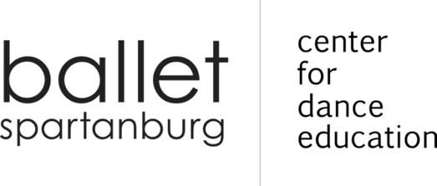
2021-2022 ADULT BALLROOM SCHEDULE

BALLROOM DANCE
MONDAYS 7:00 - 8:00 PM
BALLET SPARTANBURG STUDIOS
INSTRUCTOR: MARIAN NORMAN

DANCE | SESSION DATES |  | DESCRIPTION
FOXTROT  SINGLE: $60  COUPLE: $100 | AUGUST, SEPTEMBER & OCTOBER |  | You will learn the basics of partnership dancing as well as various rhythms & patterns.
 | AUGUST | SEPTEMBER & OCTOBER
 | 23, 30 | 9/13, 10/4, 10/11
SALSA  SINGLE: $48  COUPLE: $80 | OCTOBER & NOVEMBER |  | A spicy, quick dance with origins from Latin America.
 | OCTOBER | NOVEMBER
 | 18, 25 | 1, 8
HUSTLE  SINGLE: $48  COUPLE: $80 | NOVEMBER & DECEMBER |  | A fun holiday dance that uses disco moves and has some features in common with Salsa and Swing.
 | NOVEMBER | DECEMBER
 | 15, 22, 29 | 6
SWING  SINGLE: $48  COUPLE: $80 | JANUARY |  | East Coast Swing is totally energetic and the most versatile dance in the world.
 | JANUARY | HAPPY NEW YEAR
 | 3, 10, 24, 31 | 2022!
RUMBA  SINGLE: $48  COUPLE: $80 | FEBRUARY |  | Known as the “Dance of Love”; the beautiful, romantic, music moves you to dance.
 | FEBRUARY | PERFECT FOR
 | 7, 14, 21, 28 | ST. VALENTINE’S
WALTZ  SINGLE: $60  COUPLE: $100 | MARCH & APRIL |  | Smooth and full of elegance; one of the most popular and classical ballroom dances.
 | MARCH | APRIL
 | 7, 14, 21, 28 | 4
CHA CHA  SINGLE: $60 COUPLE: $100 | APRIL & MAY |  | A Latin Dance which is playful, flashy, and fun.
 | APRIL | MAY
 | 11, 18, 25 | 2, 9

Each adult is required to complete the 2021-2022 Adult Registration Form just once per school year. Any subsequent classes or sessions will be annotated on the registration form.

Session prices do not include registration fees. Each adult must pay a one-time registration fee of $15 per year.

Ballroom is paid per session and rates may not be pro-rated, carried forward, or refunded. Any cancelled classes will be rescheduled.

200 East Saint John Street | Spartanburg SC 29306 | 864-583-0339 balletspartanburg.org

