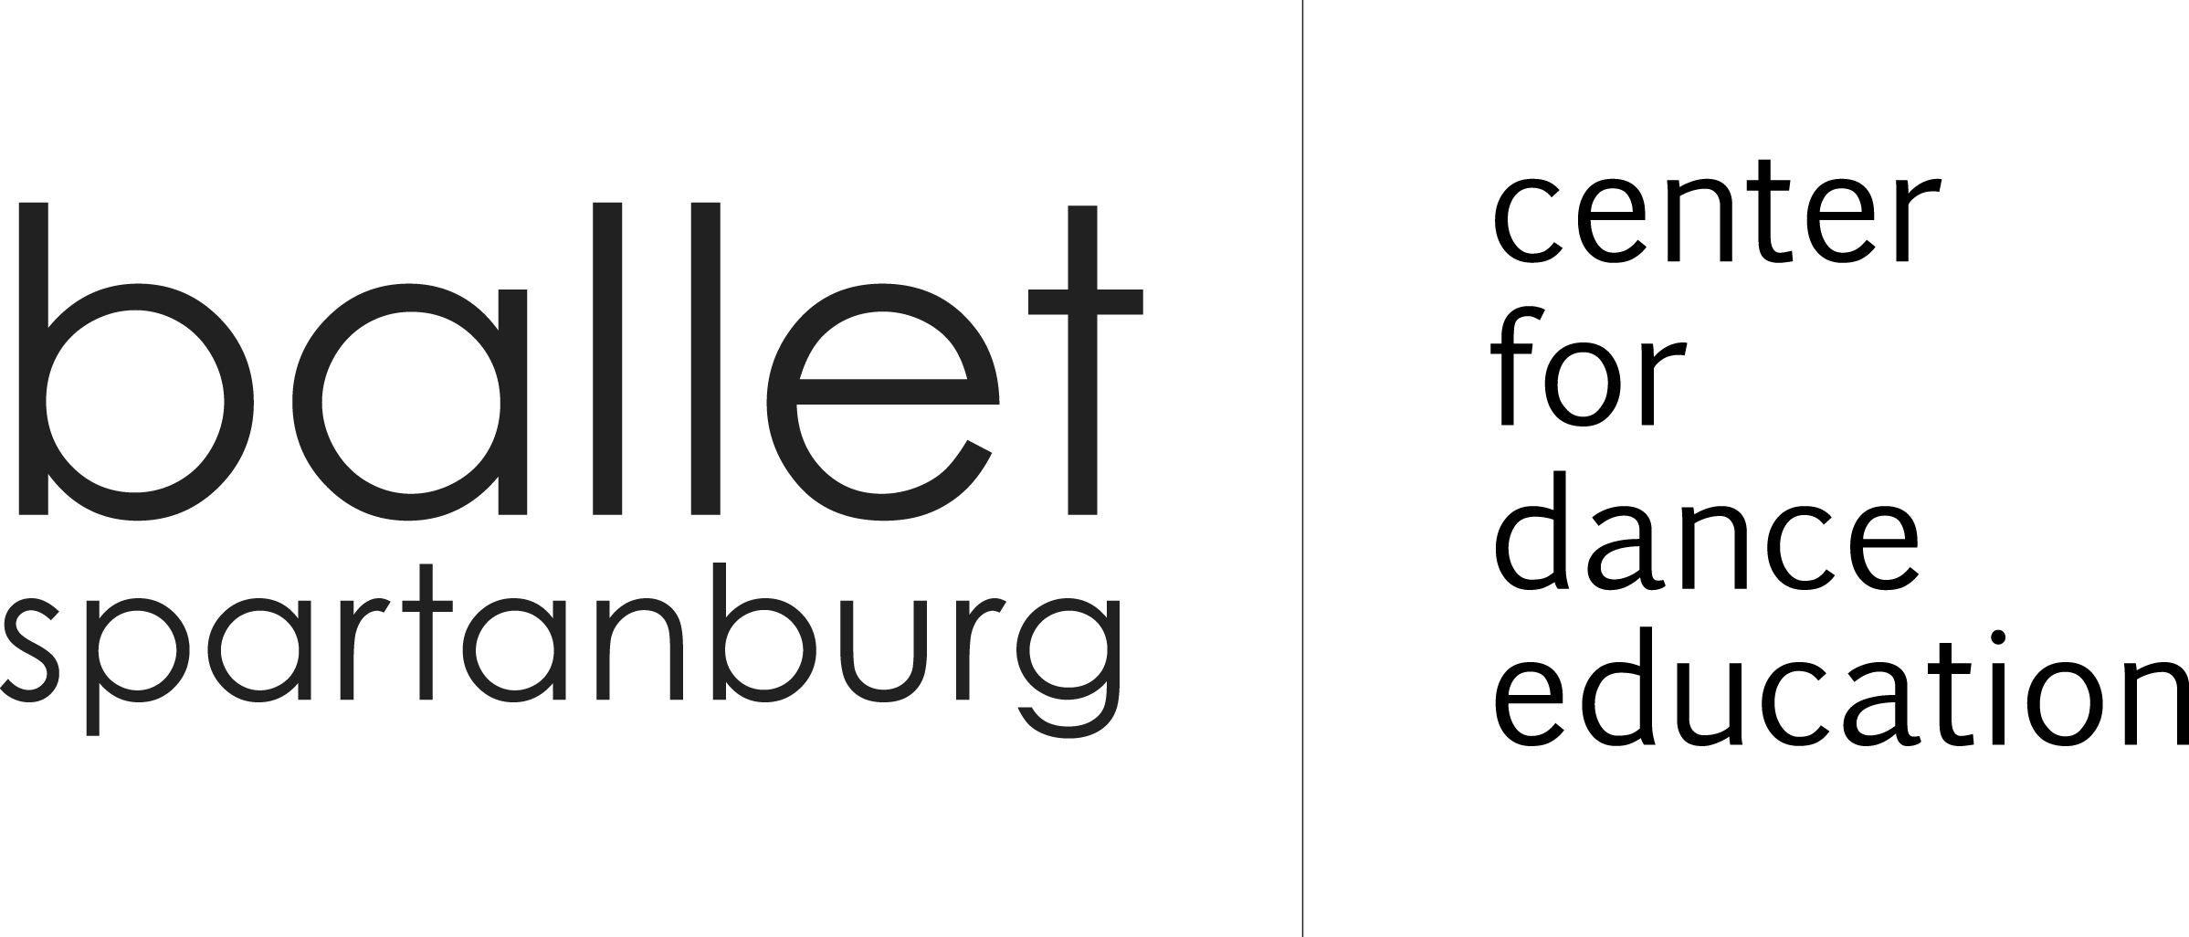
2021-2022 ADULT REGISTRATION FORM
Please print and complete in full
A 2021-2022 Adult Registration Form must be completed for all adults attending CFDE classes just once per year.
Subsequent classes or sessions will be annotated on the completed registration form.

□ COUPLE (Ballroom) □SINGLE

(CHECK ONE)

ADULT #1 INFORMATION
NAME

STREET ADDRESS

CITY, STATE, ZIP CODE

PHONE: □Home □Work □ Cell

EMAIL (Important for CFDE communication

- I agree that I am physically fit and will not make a claim against, sue, attach the property of or prosecute Ballet Spartanburg, their agents, sponsors or employees for damages, death, personal injury or property damages I may sustain as a result of my participation in these activities.

- I am aware that this is a release of liability from myself and Ballet Spartanburg and its agents, sponsors and employees, and I have signed it of my own free will.

SIGNATURE

□ $15 Registration Fee Paid (One-time fee)
ADULT #2 INFORMATION
NAME

STREET ADDRESS □Same as #1

CITY, STATE, ZIP CODE □Same as #1

PHONE: □Home □Work □ Cell □Same as #1

EMAIL □Same as #1

- I agree that I am physically fit and will not make a claim against, sue, attach the property of or prosecute Ballet Spartanburg, their agents, sponsors or employees for damages, death, personal injury or property damages I may sustain as a result of my participation in these activities.

- I am aware that this is a release of liability from myself and Ballet Spartanburg and its agents, sponsors and employees, and I have signed it of my own free will.

SIGNATURE

□ $15 Registration Fee Paid (One-time fee)

Tuition prices do not include registration fees. Each adult must pay a one-time registration fee of $15 per school year.

Dance classes paid monthly PRIOR to class. Ballroom is paid per session.

Dance and Ballroom rates may not be prorated, carried forward, or refunded. Any cancelled classes will be rescheduled.

DANCE |  | AUG  AUG |  | SEP |  | OCT |  | NOV |  | DEC |  | JAN |  | FEB |  | MAR |  | APR |  | MAY
CHECK BOX FOR  CLASSES ATTENDING |  | PAYMENT |  | PAYMENT |  | PAYMENT |  | PAYMENT |  | PAYMENT |  | PAYMENT |  | PAYMENT |  | PAYMENT |  | PAYMENT |  | PAYMENT
 | Irish Step Mon. | $36 |  | $36 |  | $48 |  | $60 |  | $24 |  | $48 |  | $48 |  | $48 |  | $36 |  | $48
 | Jazz Thur. | $12 |  | $60 |  | $48 |  | $36 |  | $36 |  | $48 |  | $48 |  | $60 |  | $36 |  | $48
 | Tap Thur. | $12 |  | $60 |  | $48 |  | $36 |  | $36 |  | $48 |  | $48 |  | $60 |  | $36 |  | $48

PAID

BALLROOM | FOXTROT |  | SALSA |  | HUSTLE |  | SWING |  | RUMBA |  | WALTZ |  | CHA CHA
 | PAYMENT |  | PAYMENT |  | PAYMENT |  | PAYMENT |  | PAYMENT |  | PAYMENT |  | PAYMENT
Single Rate | $60 |  | $48 |  | $48 |  | $48 |  | $48 |  | $60 |  | $60
Couple Rate | $100 |  | $80 |  | $80 |  | $80 |  | $80 |  | $100 |  | $100

PAID
CHECK □ CASH □ MC □ VISA □
____________________________________
NAME ON CARD
____________________________________ ________
CREDIT CARD NUMBER CVV
____________ _____________
EXP. ZIP CODE
REGISTRATION FEE(S) ______________
TUITION TOTAL ______________

TOTAL PAID ______________

